SMART NUTRI CART
The Smart Nutri Cart is an innovative ESP32-powered hardware device that can be mounted on shopping carts, enabling real-time analysis of food product nutrition based on user-selected lifestyle concerns like diabetes, cholesterol, or hypertension and delivering instant recommendation and alternatives if required.”

PROJECT DESCRIPTION :

Smart Nutri Cart is an ESP32-powered smart shopping cart system designed to control lifestyle diseases by providing real-time nutritional analysis and recommendations to the customer.
The customer select their health concern (Diabetes, Cholesterol, Hypertension) and severity level (Mild/Moderate/Severe), then scan product barcode using a dedicated scanner . The system instantly analyzes nutrition data against health-specific thresholds and displays results on an LCD screen with healthy alternatives for risky products.

PROBLEM STATEMENT :

Approximately 1 in 10 adults in Kerala has diabetes or a similar diet-sensitive condition. Supermarket shoppers lack accessible, real-time nutritional guidance when selecting packaged food. Labels bury critical information in fine print, and there are no convenient tools that adapt recommendations to an individual's health severity (mild, moderate, severe). This information gap leads to poor food choices at the point of sale, increasing health risks and undermining disease management for a significant portion of the population.

END TO END USER EXPERIENCE JOURNEY :

- Power ON: Customer activates ESP32-powered cart.
LCD displays "Choose health concern."

- Select Mode: Customer presses Diabetes / Cholesterol / Hypertension button.
LCD displays “choose the severity level.”

- Customer selects severity level (mild / moderate / severe).

- Customer chosen mode
ACTIVATED.

- Customer scans the products via the scanner available with the device.

- DISPLAY OF RESULTS: LCD shows instant analysis. For example,"RISK: 65g sugar" or “Highly Recommended”.Suggest
alternatives.

- Continue shopping : Same cycle repeated
for multiple items.
Customer can switch modes as needed midway.

- After shopping,
RESETs for next customer.

TECH STACK :

Hardware Components :

ESP32 DevKit V1 :

It serves as the main brain, processing barcode data, running health algorithms, hosting WiFi access point , controlling LCD display, and reading button inputs for mode selection.

16 x 2 LCD I2C Module :

It provides instant visual feedback to users, it displays health risk warnings and alternatives.

Tactile Push Buttons :

It enables user interaction.
It serves as selectors for health concern and severity level and reset.

BarCode Scanner :

A dummy phone is used as bar code scanner as of now.
The scanned barcode data sent to ESP32's web server over WiFi connection.

USB Type C
Breadboard
Jumper Wires

Software :

Arduino IDE :

Primary development environment for ESP32 programming.

Arduino libraries used :

*ESP32 Core Board Package (v3.0.0)

*LiquidCrystal I2C Library (v1.1.4)

*ESPAsyncWebServer Library (v1.2.3)

Open Food Facts API :
It is the ideal nutrition database for Nutri Cart.

PROJECT OUTCOME :

The Smart Nutri Cart project breaks through traditional supermarket shopping by integrating real-time barcode nutrition analysis directly into the cart, eliminating the need for manual label reading or smartphone apps.
We achieved a functional ESP32-powered prototype that delivers risk assessments for diabetes, cholesterol, and hypertension across wide range of products using Open Food Facts API integration.

FUTURE SCOPE OF THE PROJECT :

Eliminating separate buttons and LCD

The physical push buttons and character LCD can be replaced by a single touchscreen interface, combining input and output into one module and removing the need for a separate scanner section.

AI-based intelligent suggestions
AI models can be integrated with the touchscreen interface to provide more intelligent alternative suggestions, such as recommending likely solutions and alternatives.
Handling multiple concerns
The current prototype is designed to handle only one concern at a time.The system architecture can be extended to process and track multiple concerns in parallel.
Scope for wider applications
The type of concern handled by the system is not limited to the current use case and can be scaled to a wide range.

CONNECTION DIAGRAM :

WORKING PROTOTYPE :
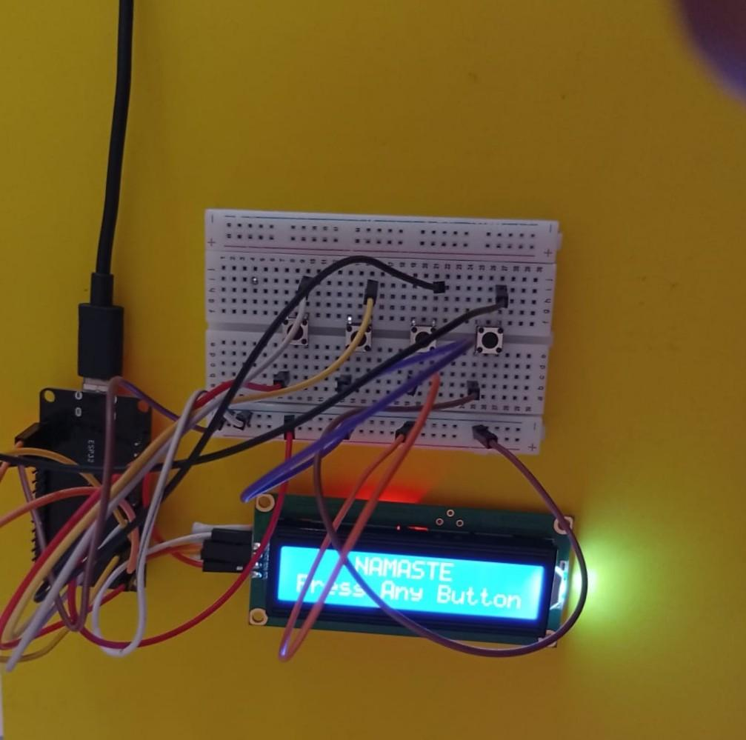
COMMERCIALISED END PRODUCT :
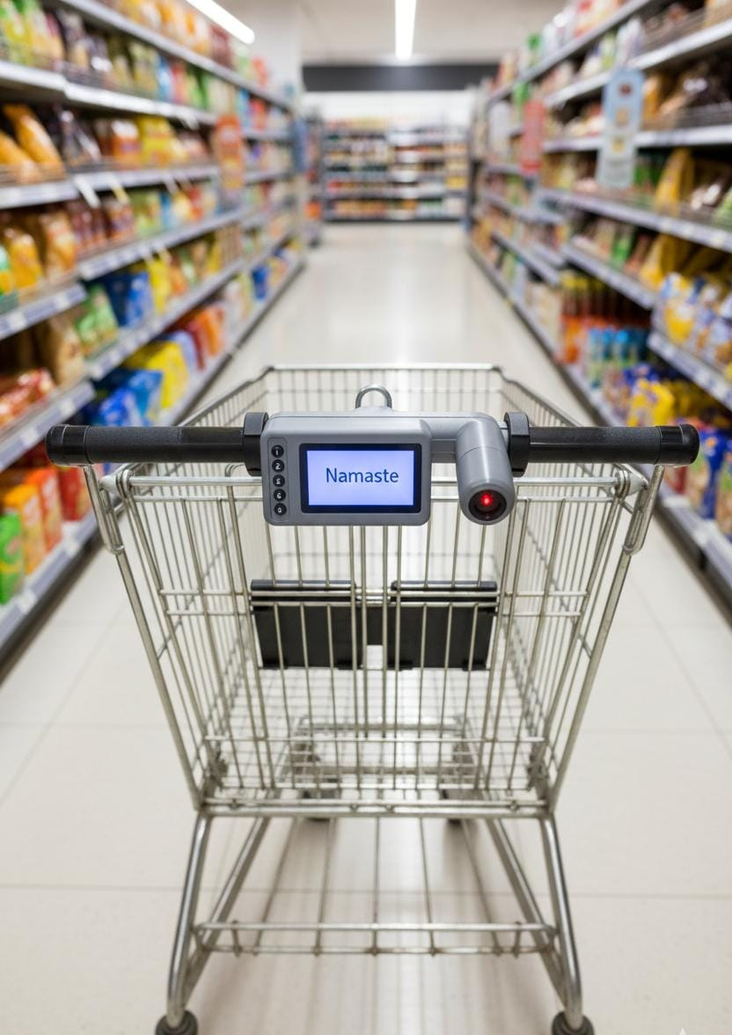

TEAM MEMBERS :
Nile V Sajan nilevsajan@gmail.com
Parvathy M parvathymanjusha@gmail.com
Gaurinandana A gaurianitha@gmail.com

